Practical 2

Aim: Configure NFS server to share directories on your network.

**Step 1:** Install the NFS server on your Ubuntu 16.04 using the following command

sudo apt-get install nfs-kernel-server

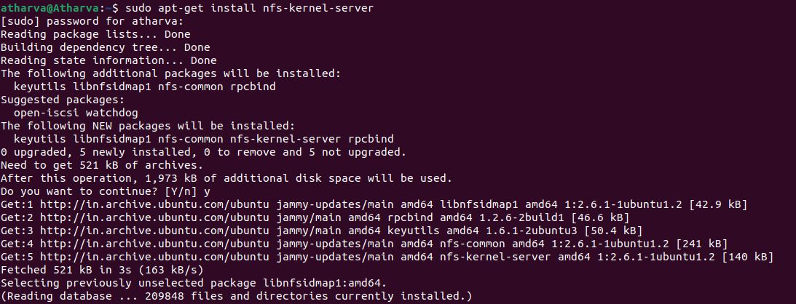

**Step 2:** Once the installation is done we have to change the domain name of our domain which will be as same as of our root machine

sudo nano /etc/idmapd.conf

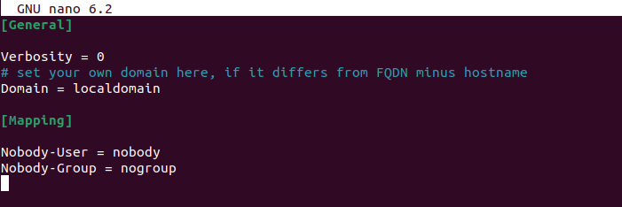

**Step 3:** Now open the exports file to check if it's there or not. It is basically a list for file systems which might be exported via our NFS server

sudo nano /etc/exports

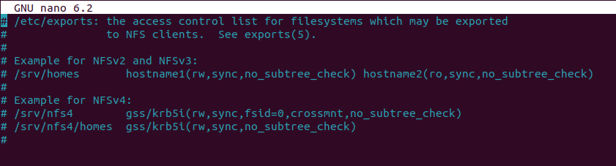

**Step 4:** Now restart the NFS server you've installed in your Ubuntu at the start of the practical using the following command

systemctl restart nfs-server

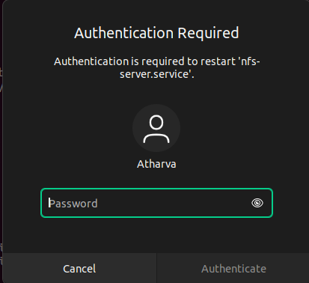

**Step 5:** In this step we will mount our nfs server into our home directory using the following command

mount -t nfsdlp.srv.world:/home/home



**Step 6:** In this step we will display the information mounted by our NFS server, the 'df' command is used to display the information about total space and available space on a file system.

df -hT

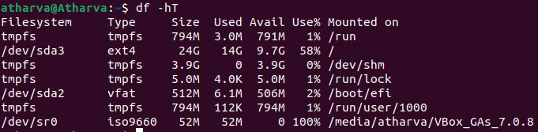

**Step 7:** In this step we will configure the mounting on fstab to mount it when the system boot

sudo nano /etc/fstab

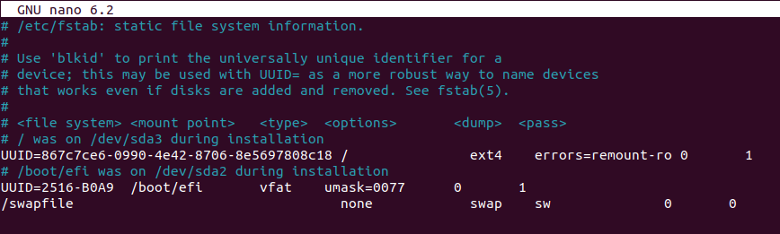

**Step 8:** Now we will install our auto mounting fstab using the following command

sudo apt-get install autofs

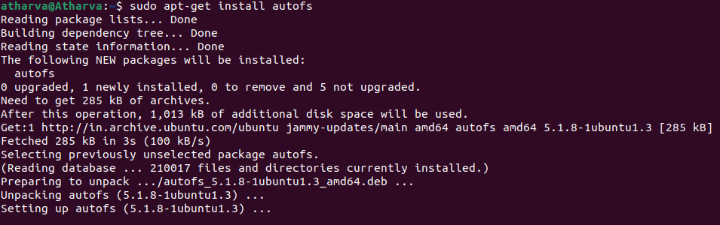

**Step 9:** After getting done with the installation we have to open and check whether the auto.master file was created or not. This will be done by using the following command

sudo nano /etc/auto.master

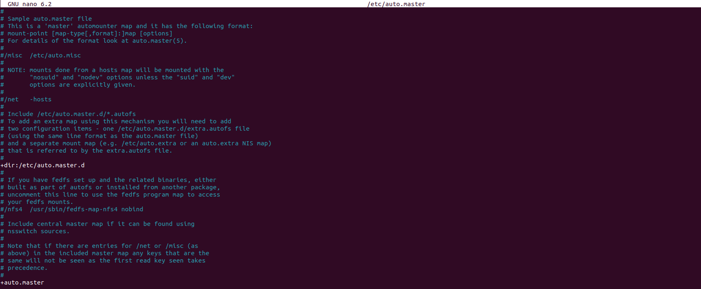

**Step 10:** After checking the auto.master file we will need to create a directory(file) in which we will be adding our mounted data.

sudo mkdir /mntdir



**Step 11:** Now after making the directory we will restart the auto mounting fstab, using the following command.

systemctl restart autofs

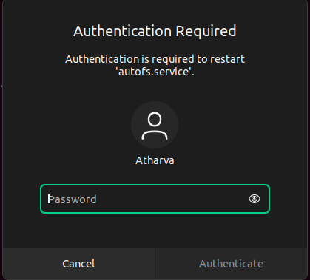

**Step 12:** Now we have to mount the data, before doing that we will need to change the current directory we are in to the directory we made for data mounting purpose (mntdir). For changing directory we will use "cd"

cd /mntdir



**Step 13:** We have to mount the data into mntdir which was mounted when we installes NFS and auto fstab in the mount directory, we will use grep command. It can be done as follow:

cat /proc/mounts | grep mntdir

